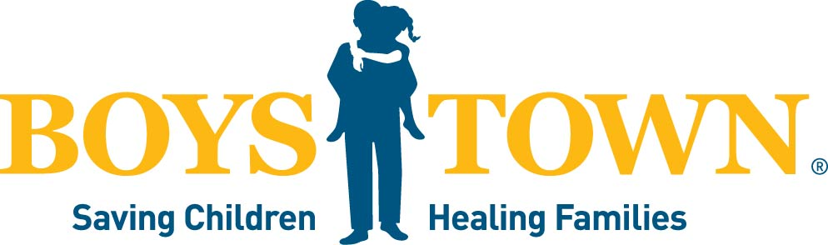
FOR MORE INFORMATION
boystown.org
GENERAL INFORMATION
- Boys Town celebrated 100 years on 12.12.17
- Boys Town directly served more than 197,000 children and families in 2025
- Boys Town has 8 sites around the country
  - Nebraska
  - Iowa
  - Nevada
  - Louisiana
  - South Florida
  - Central Florida
  - North Florida
  - New England
- Over 1.77 MILLION users of Boys Town online tools and resources (Your Life Your Voice app downloads, Parenting.org users, Boystown.org users, and other service-based websites)
- Boys Town consultants work directly with families in their homes to help them overcome complex challenges, strengthen parenting skills and create safer, more stable family environments through the In-Home Family Services® program.
- Residential Treatment Center (RTC) at Boys Town offers secure, medically directed care for children and teens ages 5–17 facing severe behavioral and mental health challenges, providing families with intensive support when other interventions have not worked.

BOYS TOWN
Media Fact Sheet
BOYS TOWN NATIONAL HOTLINE NUMBERS
- 106,611 Hotline Contacts Received in 2025
- Stopped 459 suicides in progress in 2025
- Top 5 reasons for young people contacts:
  - 27% Suicide Ideation
  - 19% Anxiety
  - 7% Significant Other
  - 6% Loneliness
  - 6% Parent Child Relationship
- Answered more than 10.9 million calls to our crisis and suicide prevention hotline since 1989
- Over 15,000 Suicide Ideation contacts

BOYS TOWN EDUCATION SUPPORT NUMBERS
(For teachers, students and families)
- 413 schools trained/served
- 5,071 educators trained
- 170,957 students positively impacted in schools
BOYS TOWN MENTAL HEALTH SERVICES AND SUPPORT NUMBERS
- Inpatient Psychiatric Unit: 2,151 Patient Days
- Outpatient Psychiatric Unit: 15,030 visits
- Psychiatric Residential Treatment Center: 26,436 Patient Days
- Center for Behavioral Health: 37,821 visits
BOYS TOWN NATIONAL RESEARCH HOSPITAL
- Regional center of excellence for neurological disorders, epilepsy, neuromuscular, neurogenetics, and rare diseases.
- Over 40 research labs
- Nearly 64,000 patients received specialized care
- One of the world’s leading research institutes with two MEGIN Neo MEG systems, as well as the second facility worldwide to install a high-density Cerca Magnetics optically pumped magnetometer (OPM) system comprised of 208 channels.
OTHER BOYS TOWN RESOURCES:
- Boys Town National Hotline (1-800-448-3000)
- Boys Town National Research Hospital
- www.boystown.org/parenting
- www.yourlifeyourvoice.org

